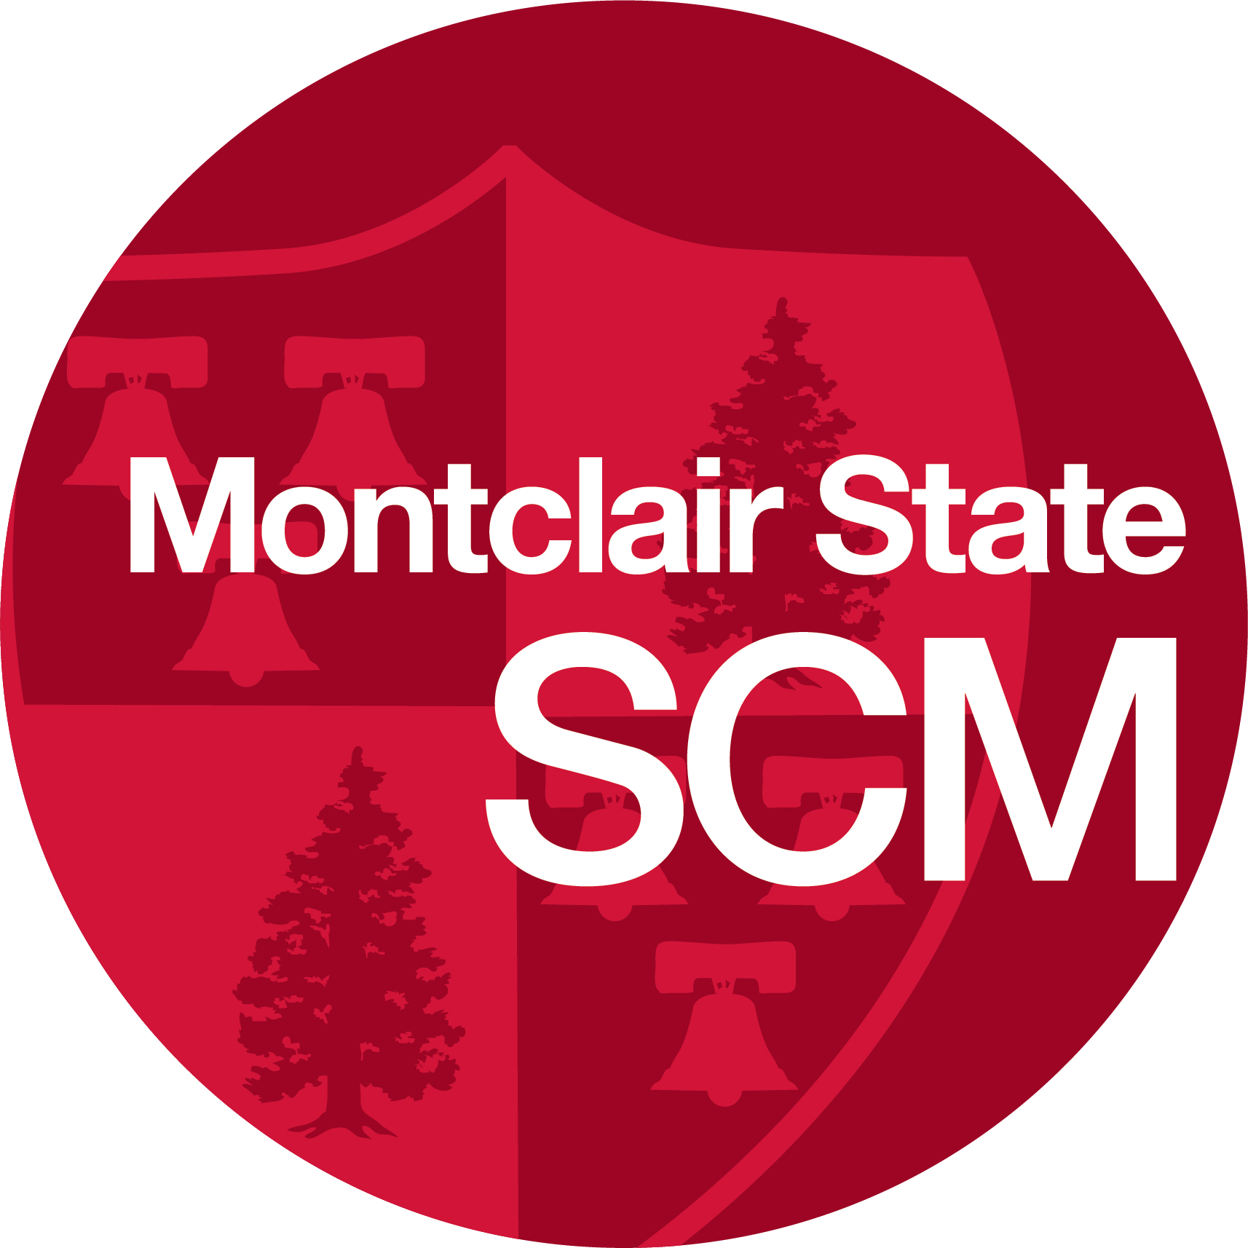

CMST 435 Spring 2022
“HAWK COMMUNICATIONS”

Professor: Keith Green, APR
Class Day, Time and Location: Wednesday 10:45 a.m.-1:15 p.m., Room 1011 SCM
Office Hours: Email me to schedule an appointment
Phone and email: 732-870-7977 (cell); greenk@montclair.edu
Agency website: www.hawkcomms.com

COURSE DESCRIPTION

Hawk Communications was established to give students the opportunity to work with real clients and gain hands-on, strategic communication experience. Agency clients include internal departments/programs from Montclair State and area businesses and nonprofits. This semester, the agency will work with the following groups/companies*
- Garden State Wine Growers Association (tentative)
- New Jersey Warriors
- Monarchs
- Reelabilities
- Hawk Communications
- Autism MVP Foundation
- National Music Council of the United States
- Montclair State’s Global Center on Human Trafficking (tentative)
- American Dream (this is tentative because it would require off-site work).
- SCM Coordination Desk (see below)
One of the exciting aspects of this course it that it is held in Room 1011 of the School of Communication and Media building. This room has transformed into an exciting, state-of-the-art teaching and learning space called the Joetta Di Bella and Fred C. Sautter III Center for Strategic Communication. This space will be on par with the top social media listening and learning centers (there aren't many of them, actually) in the country. We will have access to tools and technology that will help better prepare you for your first job and beyond. As a student in this class, you will be among the first to have access to this space, which will include six large smart TV's, a small studio and social media listening and monitoring tools.
Outside of the client work, I will need one student to participate in the Coordination Desk (a collaborative effort among the SCM media organizations where students collaborate on an initiative called #Focus. Student media organizations and clubs work together to highlight an important societal issue. Past topics include racial justice, immigration and climate change.
The “Coordination Desk” meeting (as of now) is from 1-2 p.m. on Tuesday. (This would be like your weekly client meeting). The role of Hawk Communications and the student working on this will be to figure out how we can internally and externally promote the #Focus initiative this semester by creating content and writing stories about the project.

*Subject to changes/additions

COURSE GOALS

The main goal of this course is to familiarize you with client work and to gain experience across a variety of industries. Essentially, this class is an internship and will provide you with the opportunity to do tactical work for real clients and be part of account teams comprised entirely of you and your fellow students. The accounts you will work on will be based on your interest and/or how I assign accounts to you. While the type of work will vary depending upon client needs, students can expect to do the following:

- Social media management and posting
- Content creation and editing (photos, videos, written content)
- Media relations (earned media pitching)
- Brainstorming/creative concepting
- Planning and attending events/event management
- Vendor communication/management
- Fundraising

Students will also gain experience in the following areas:
- Teamwork
- Team/colleague management
- Client management
- Meeting deadlines
- Situation Analysis/SWOT and Recap reporting
- Leadership skills
- Thought leadership (writing)
- Reporting/recapping

Course Delivery and Canvas

All course materials, including a copy of this syllabus, will be posted on the MSU Canvas site (https://montclair.instructure.com).

Class will be conducted via the Hawk-to-Hawk format, meaning that each class will be in person. Unless university or other guidelines dictate, there will not be a virtual option for this class.

Technology Requirements

Smartphone and laptop. You will need a laptop to log onto class and/or to complete assignments. If you don't have a laptop, you may borrow one at no charge from the university's tech department as noted above. Having a smartphone is not mandatory but will be useful.

Communication

Email is the preferred method of communication. If you need to reach me, please send an email to the address provided above. I check my email every day, several times a day. If you have an emergency or need to speak with me immediately, you can text or call me at 732-870-7977.

Course Policies and Other Info:

- Attendance for this class is mandatory. This class meets once a week, so more than one missed class will cause your grade to drop by one full letter grade. THREE ABSENCES IS AN AUTOMATIC FAILURE. If you develop a long-term illness, COVID or serious issue during the class, talk to me about it so that we can discuss your options. Click here for “withdrawal procedures and refund policy.”
- Please be punctual and allow yourself time to adjust for technological issues. If you are late, it is your responsibility to make sure you are marked present in my grade book. If you are more than 10 minutes late for three classes, I will count that as one “miss.”
- Class cancellation: I will post a note in Canvas and send an email if I need to cancel class due to an emergency. Please check your email for alerts regarding any university-wide closures.
- Late assignments. Deadlines are extremely important in public relations, media and the “real world,” so it is critical to submit your client work and assignments on time based on the deadlines I provide or your clients outline. Submitting client work that is late is unprofessional and unacceptable. If a deadline is provided, stick to it or be sure to ask for an extension or clarification if it is needed.
- Class professionalism. Please read this carefully. Unless otherwise instructed for an assignment, do not use your phone. You are expected to actively participate in class, listen politely to me, your classmates and our clients, and be respectful. Your class behavior will be factored into your grade.
- Academic integrity standards will be strictly enforced. You will be working mostly as part of an account team. That said, there will be some individual work such as the thought leadership piece, so make sure the work you do is your own.
- Psychological and Counseling Services: More than ever, this is important. You can make an appointment at the Counseling and Psychological Services by calling 973-655-5211 or visit one of the many “Let’s Talk” sessions held in multiple places on campus and remotely. You can review the full range of services offered here and schedule in-person and remote appointments as well. If you are currently in a situation in which you feel unsafe and on campus, call Campus Police at 973-655-5222 or 911 off campus.

ASSIGNMENTS AND GRADING
Your grade will be based on the following, 1000-point scale:

Attendance, in-class professionalism and client feedback: 100 points
Self and peer evaluation document: 50 points. You will receive full credit for completing this form on-time and with honesty and candor about your work, as well as the work completed by each person on your account teams.
Client Recap Documents (2): 300 points (Group PPT or Google Slide Project). Details to follow.

Client Work: 400 points**This is group work but individually graded based on the quality and quantity of your work through the client group discussion boards and the work you help produce. There will be 10 client updates for each student to provide for each client via discussion boards (Feb. 9- April 20) There will be deadlines each week and we will also discuss any challenges you are facing, training or resources you need or other issues. Feedback from your peers will be taken into consideration for part of your grade

Thought Leadership Piece: 150 points (individual). Rubric/info to be provided. See more info here.

** “Fire the Freeloader:” Throughout the semester, you can “fire” a group member who fails to pull his/her weight. To fire a group member:

Email the “freeloader” with a warning message. CC all group members and me.

The “freeloader” will have 24 hours from the time the warning message is sent by other group members to respond to the message. Not responding to the warning message will result in the firing of the “freeloader.”

I will arrange an offline consulting session with the “freeloader” within 48 hours from the time the responding message is sent by the “freeloader.”

If the “freeloader” fails to have an offline consulting session with me within the designated time frame or gets a second warning message by group members after the consulting session, the “freeloader” will be fired.

If fired, the “freeloader” will fail the group part of the assignment and cannot be a group member of that team for the rest of the semester. If the “freeloader” is fired, remaining group members will not be able to have another group member. Therefore, please try your best NOT to fire any group member and ensure that everyone is doing his/her share of the work.

TENTATIVE SCHEDULE

Week 1, Jan. 19:
Welcome, introductions, syllabus review, career and class goals.

Weeks 2 and 3 (Jan. 26 and Feb. 2)
Client visits

Week 4, Feb. 9
- Client discussion/planning
- Lecture and training as needed
- Client intake call/writing agendas/setting expectations
- First discussion board/individual progress (due next week)

Weeks 5-15, Feb. 16-April 27
- Keith’s Career Counseling session
- Periodic guest speakers
- Lecture and training as needed
- Planning and execution of client work
- Discussion board/individual progress (last one is due April 27)

April 27
- Thought Leadership piece due
- Client recap documents due

May 4
- Client Presentation rehearsals

May 11
- In-class presentations (to clients) due
- Peer evaluation due

LETTER GRADES

Letter grades for the entire course will be assigned as follows. A 1000-point system is used based on the percentages above.

Letter Grade | Percent Grade
A | 94-100%
A- | 90-93.9
B+ | 87-89.9
B | 83-86.9
B- | 80-82.9
C+ | 77-79.9
C | 73-76.9
C- | 70-72.9
D+ | 67-69.9
D | 63-66.9
D- | 60-62.9
F | Below 60

MSU PROTOCOLS & RESOURCES

- It is important for all students to be familiar with University policies and procedures. Visit the University Policies and Procedures website (http://www.montclair.edu/policies/) for details.
- Montclair State University’s webpage on academic honesty and integrity (http://www.montclair.edu/policies/student/student-conduct/academic-honesty/) includes resources on integrity, academic standards, plagiarism, and related topics.
- Information about library resources can be accessed on the MSU library website (http://www.montclair.edu/library/) .
- Writing support and resources may be found in the Center for Writing Excellence (http://www.montclair.edu/center-for-writing-excellence/)
- Information for students in transition may be found on the Center for Advising and Student Transitions (http://www.montclair.edu/student-development-campus-life/center-for-advising-student-transitions/)

COMMITMENT TO ACCESSIBILITY

Students with disabilities or special circumstances should contact me as soon as possible to ensure that your needs are met in the course. Reasonable accommodations are available for students with a documented disability. If you have a disability and may need accommodations to fully participate in this class, please contact the Disability Resource Center (http://www.montclair.edu/disability-resource-center/) or by phone at 973-655-5431.

TECHNICAL SUPPORT
- To get help troubleshooting problems using Canvas, you may call the IT Service Desk (http://www.montclair.edu/oit/tech-solutions-center/it-service-desk/) directly at 973-655-7971 or via email at itservicedesk@mail.montclair.edu.
- Within Canvas you will also find a link titled “Help” in the global navigation. This provides links to chat, email or phone support. The Canvas Student Guides provide many answers to common questions related to Canvas.
- Minimum Computer Requirements:
  - What are the basic computer specifications for Canvas?
  - Which browsers does Canvas support?

